Task 21

Q1.

* launch the browser.
* Load the url <https://the-internet.herokuapp.com/>
* Switch the iFrame
* Locate the tag and type the text as ”Hello People”
* Close the browser

Script:

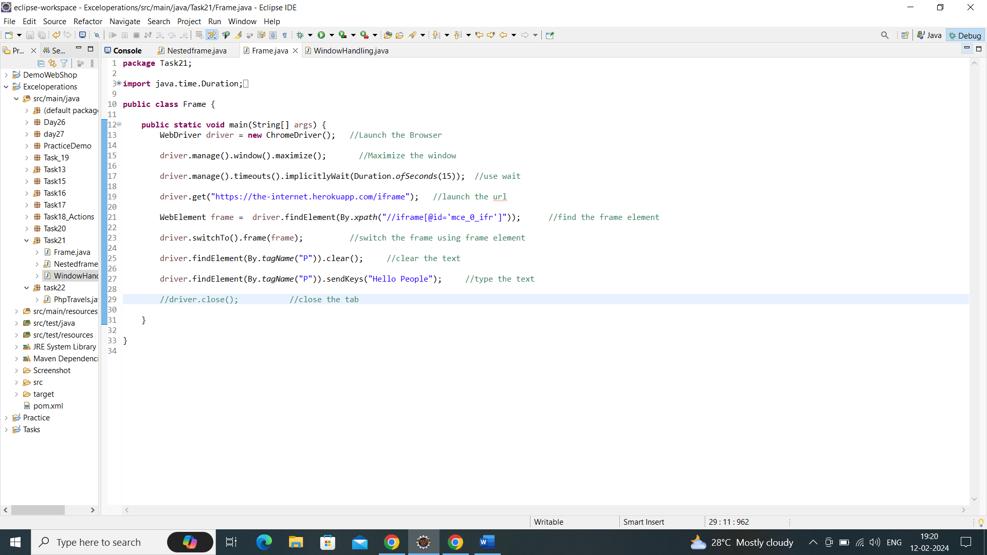

Output:

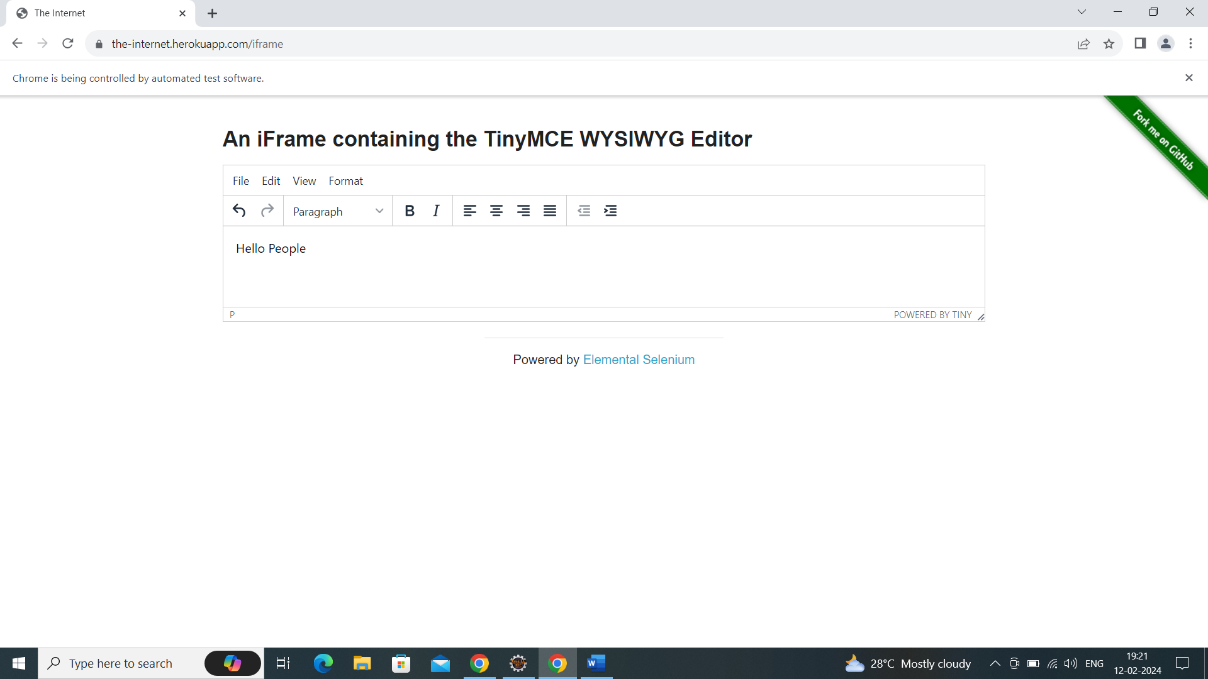

Q2.

* Launch the Browser
* Load the url <https://the-internet.herokuapp.com/windows>
* Click the click here button
* Switch to the newly open window
* Verify the text New Window
* Close the new window
* Verify the original window is active
* Quit the browser

Script:

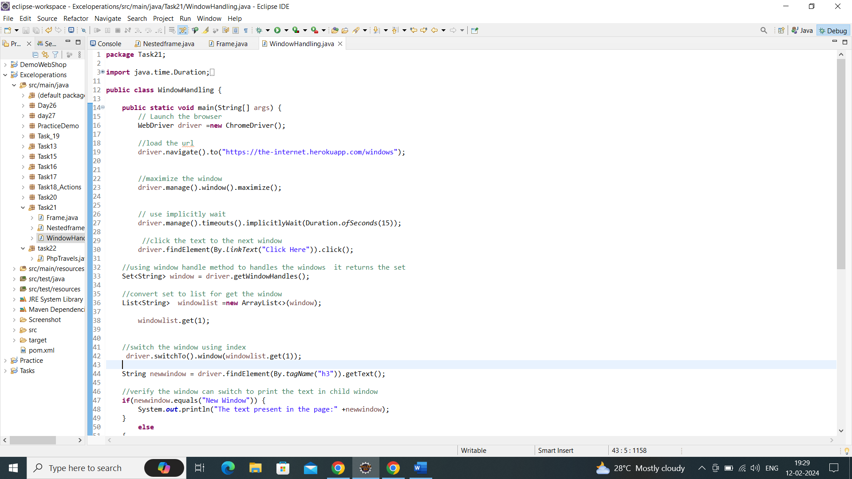

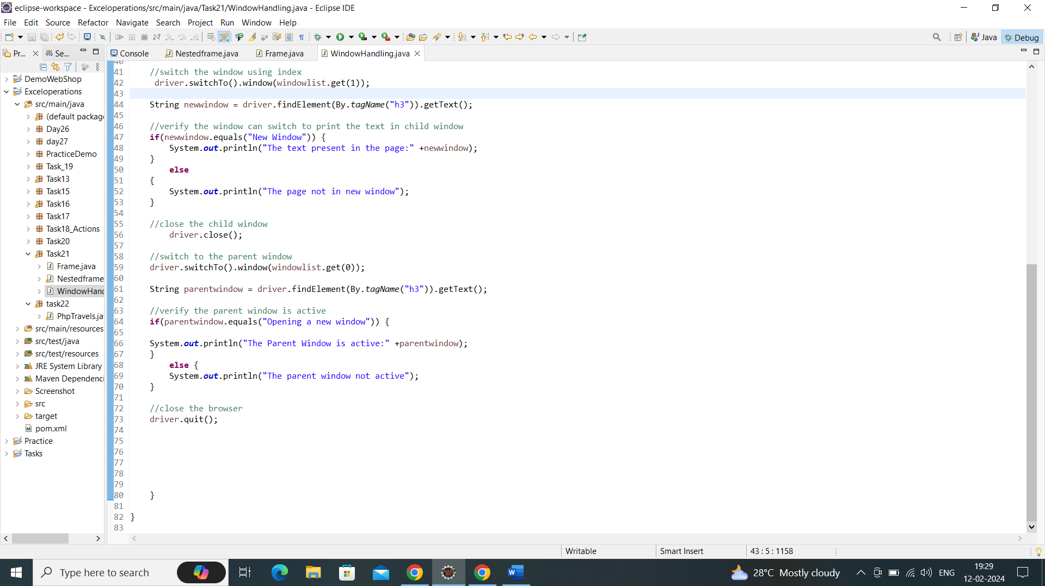

Output:

Child Window:

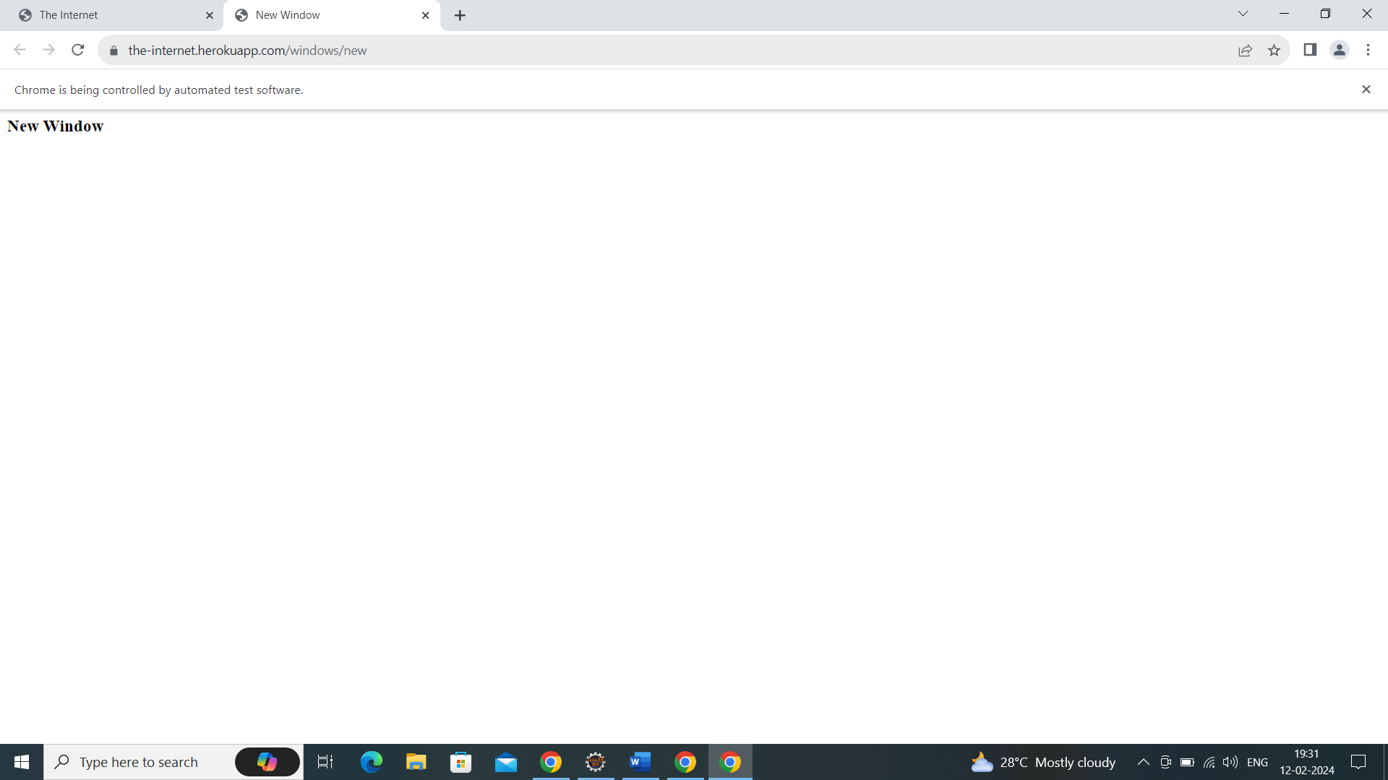

Parent window

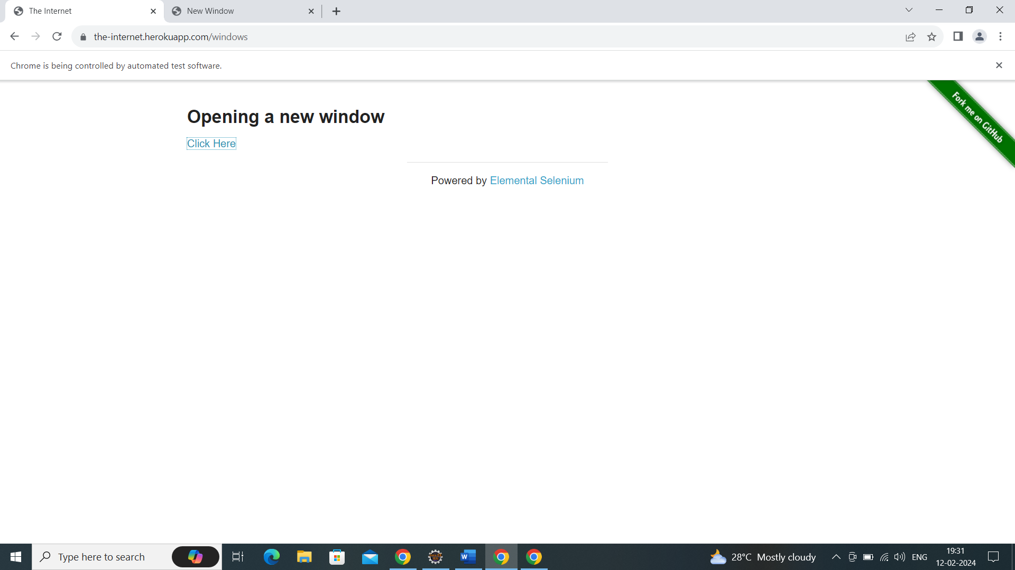

Console output:

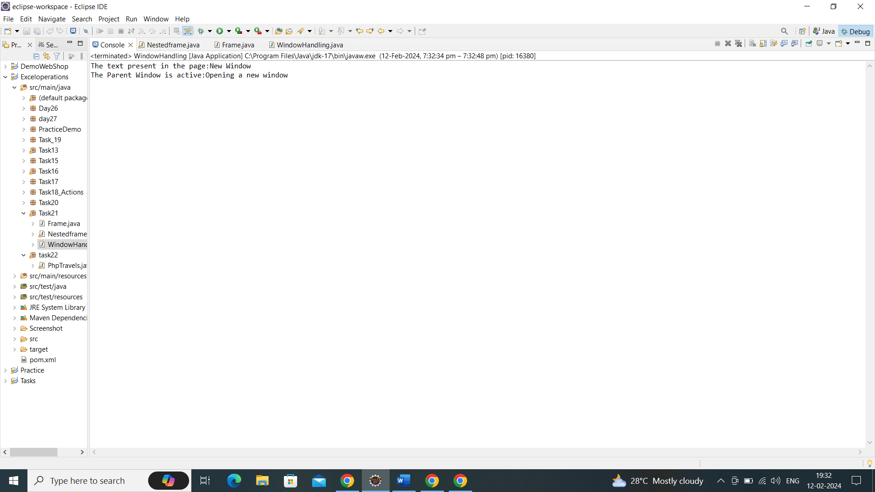

Q3.

* Launch the browser.
* Load the url
* Switch to top frame
* Verify that the top frame have three frames
* Switch to the left frame
* Verify the left frame text
* Switch to the top frame
* Switch to the middle frame
* Verify the middle frame text
* Switch to the top frame
* Switch to the right frame
* Verify the right frame text
* Switch to the top frame
* Switch to the bottom frame
* Verify that the bottom frame text
* Switch to the top frame
* Verify the page title

Script:

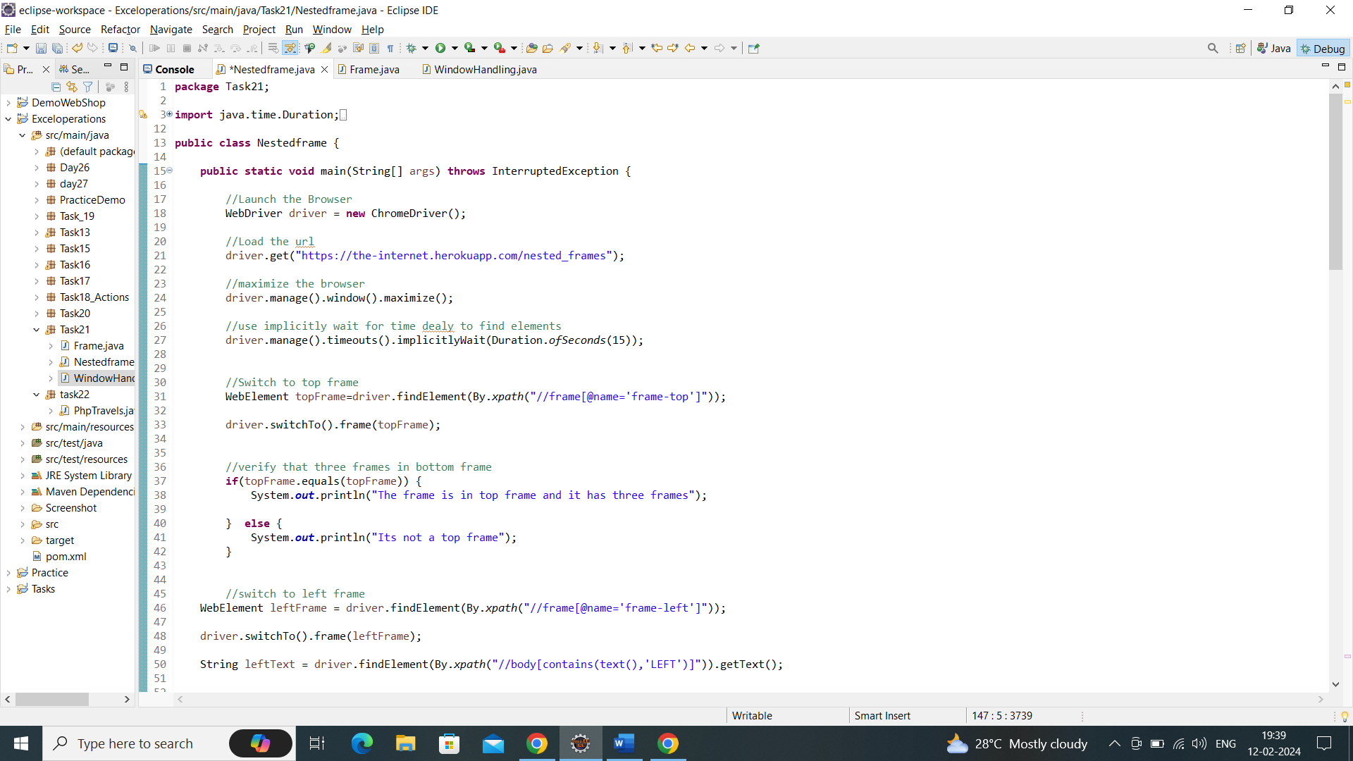

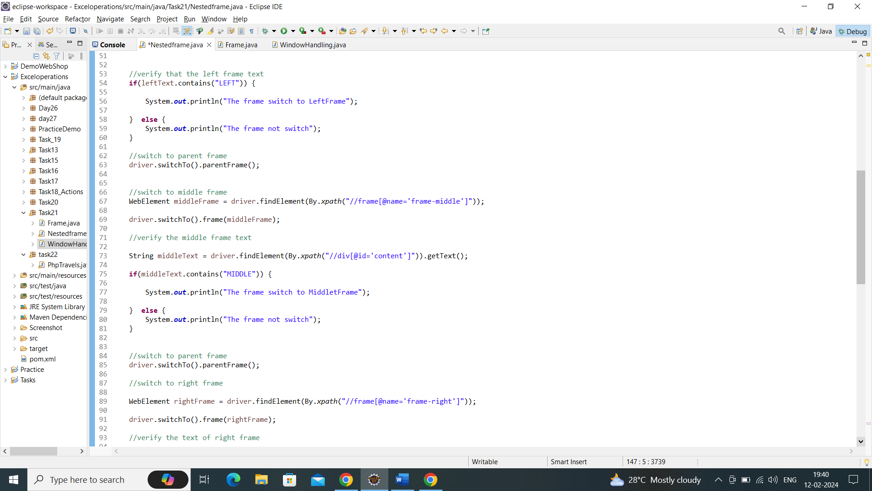

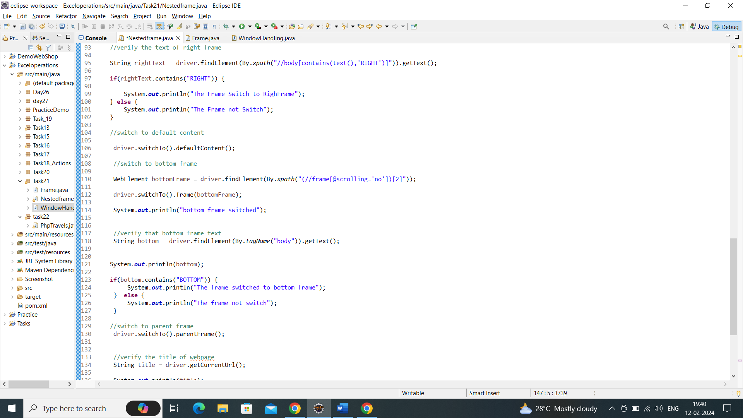

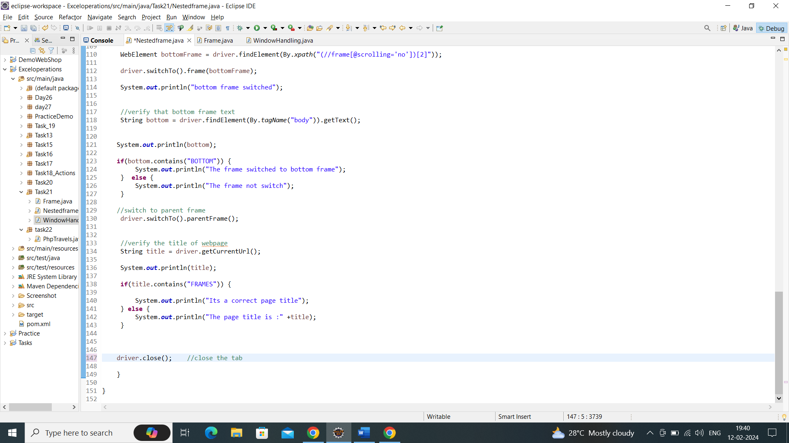

Output:

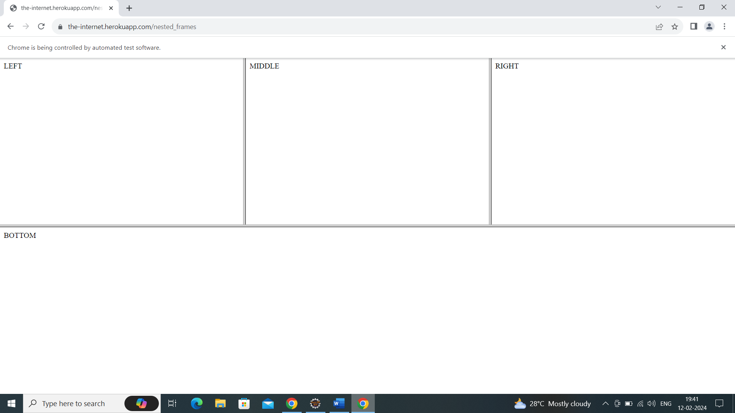

Console Output:

